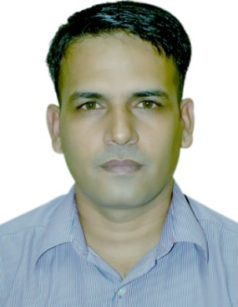

Vikram Singh

Senior lecturer (textile) Department of Handloom and textiles at Indian Institute of Handloom Technology, Jodhpur, Rajasthan. Has seven years industrial experience as production and certification engineer at different locations of country. Has more than eight years experience in academics. He has been completed DHT from IIHT Jodhpur and B. E. (Textile Technology) from MLV Textile and Engineering College Bhilwara, Rajasthan also looking after training and placement responsibility at Institute.